27th Khwarizmi International Award

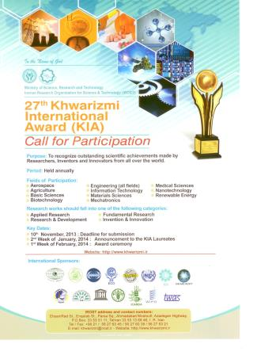
Each year, IROST celebrates and appreciates the invaluable achievements and contributions of researchers, innovators and inventors from all over the world to various fields of science at an annual awards ceremony. This year, 27th Khwarizmi International Award took place on 1 March, 2014 in Iranian Research Organization, Tehran, I. R. Iran, too.

