Report of the First Meeting of Medicinal Plants Focal Points of IORA RCSTT Cum Exhibition- Salalah – Sultanate of Oman, 23-25 June, 2014.

The First Meeting of Medicinal Plants Focal Points of IORA RCSTT Cum Exhibition was held in Salalah – Sultanate of Oman during 23-25 June, 2014. This meeting was jointly organized by the IORA RCSTT and the Oman Animal and Plant Genetic Resources Center of the Sultanate of Oman and in cooperation with Dhofar University and the Oman Animal and Plant Genetic Resources Center (OAPGRC), The Research Council (TRC) of the Sultanate of Oman. The meeting was attended by the resource persons and private sector from Egypt, India, I. R. Iran, Malaysia, Seychelles, Sri Lanka, Thailand and the Sultanate of Oman. This programme covered different topics such as policy making, regulation, standardization, technology transfer and commercialization, import and export of medicinal plants and herbal medicine and networking in IORA region in the framework of IORA Medicinal Plants Network (IORAMPNet). Totally, 17 presentations (including country reports) which mainly focused on the above topics were presented during the two-day Meeting by the participating countries as mentioned above.

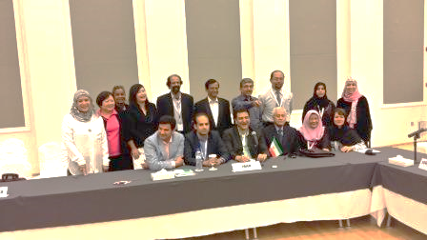

Recommendations of Participants
The delegates expressed unanimously that the meeting has been a resounding success in coming up with focused recommendations and actions as below. These would help the IORA Member States and other developing countries in formulating their plans to ensure continued cooperation for applied research, technology transfer and commercialization of Medicinal Plants and Herbal Medicine in the IORA region;
I. The meeting should be followed up at regional level to enhance cooperation on applied research, technology transfer and commercialization of Medicinal Plants and Herbal Medicine Technology in the IORA region through regional networking and annual joint activities in IORA region;
II. The participants have expressed their support to improve and reinforce IORA Medicinal Plants Network (IORAMPNet) intensively;
III. To continue the experts’ meetings programme, this event shall be held at least annually, each time hosted by one or more countries which are voluntarily selected in the previous meeting with IORA RCSTT as the biannual host.
IV. An Ad Hoc committee on Standards and Standardization for medicinal plants and herbal medicine has been established. The committee will be chaired by Dr. Anil Kumar Tripathi, CSIR-Central Institute of Medicinal and Aromatic Plants of India and focal points of Malaysia, I. R. Iran, Thailand, Seychelles, Sri Lanka, Egypt and the Sultanate of Oman as members, to meet the objective of drafting a document including introducing the system of certification of each member state in order to introduce a minimum standard acceptable to all member states for commercialization of value added products of medicinal plants and related technology in the IORA region.
V. To begin the process, the representative from Sri Lanka (Kamburawala Kankanamge Don Somathilaka Ranaweera, Bandaranayke Memorial Ayurvedic Research Institute), India (Anil Kumar Tripathi, CSIR-Central Institute of Medicinal and Aromatic Plants ), and Malaysia (Ibrahim Jantan, Universiti Kebangsaan Malaysia) proposed to host the next meeting in their respective countries in 2014/2015. India, in addition, proposed to organize the training program as well.
The date of each program will be announced by each respective focal point in consultation with the Director of IORA RCSTT. However, the participants from Egypt and Seychelles would explore the possibility of hosting one activity for IORA member states in 2015/2016.
All participants appreciated the Royal Thailand government and the focal point to host the workshop on medicinal plants in July 2014.
VI. The participant from Thailand (Chuleratana Banchonglikitkul, Thailand Institute of Scientific and Technological Research) has proposed to invite the attendees of this meeting for participation in the above program in Thailand, July, 2014.
VII. Dhofar University, Salalah, Oman initiated a proposal to start collaboration with CSIR-CIMAP, Lucknow, India, for development of a research/academic program for characterization and conservation of the biodiversity of medicinal plants in Dhofar region of Oman.
VIII. Dhofar University, Salalah, Oman initiated a signage of the Memorandum of Understanding between Dhofar University, Sultanate of Oman and Exir Gol Sorkh, Zardband Pharmaceuticals Co., Rosepharmed biotechnology Co., Magnolia flavor & fragrance Co., Kimiagar Toos Co., Goldarou Co., Iran Darouk Co., to work on developing and transferring technological methods of producing herbal medicine and any other herbal processing products.
IX. To support networking among IORA Member States and other developing countries on applied research, technology transfer and commercialization considering the following issues and activities:
- It is recommended to conduct cooperative and joint activities in applied research, technology transfer and commercialization including:
i. Technology exhibitions;
ii. Conference/Training programs;
iii. Technology transfer activities;
iv. Developing a regional vision for technology development and commercialization;

X. To invite the private sector and related industries to all future meetings focusing on developing business on medicinal plants, knowledge based production and related technologies in IORA region.
XI. The delegations request the respective governments of the member states to support their focal points of Medicinal Plants to attend all the activities of IORA RCSTT annually and that the required permission to be provided to them to attend such programs when it is needed during the year.
XII. The delegates from the member states agree to define a specific topic for each future meeting so that the expert from the member states related to the topic of the meeting could be invited.The participants have pledged to support the above activities in the region.
At the end of the Meeting, during the Closing Ceremony, all the participants were granted with the certificate of their attendance in the Meeting. On the third day of the Meeting, the private sector participants had a meeting with their counterparts in the Chamber of Commerce of the Sultanate of Oman to explore the possible areas for technology transfer and business cooperation.
It is worth mentioning that, all the participants both from public and private sectors of the IORA Member States and Dialogue Partners attending the Meeting were generously provided with full local hospitality by the Sultanate of Oman.
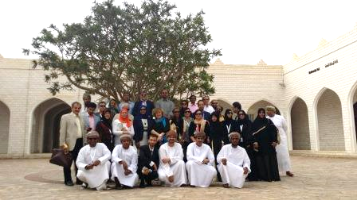

The Meeting came to an end with a sight – seeing tour for all the attendees in Salalh, Sultanate of Oman on June 27.

