International Expert Meeting / Workshop cum Exhibition on Desalination Technologies IORA Members Perspectives for Cooperation,May 5-9, 2015 - Tianjin, China
The meeting was attended by resource persons and participants from Bangladesh (one participant), China (20), I. R. Iran (6), Kenya (1), Mauritius (1), Mozambique (1), Seychelles (1), South Africa (2), Sri Lanka (3), Tanzania (1), and Thailand (1). In response to IORA Council of Ministers endorsement for signing the MoU between the IORA Regional Centre for Science and Technology Transfer (IORA RCSTT) and the Institution of Seawater Desalination and Multipurpose Utilization, SOA (Tianjin) (ISDMU) to establish the “IORA RCSTT Coordination Center for Desalination Technologies” for IORA region, this programme was organized.
This Meeting / workshop was organized as the follow up of the 1st Regional Experts Meeting and Training Workshop on "Desalination of Brackish Sea Water and Wastewater Treatment" jointly organized by IORA RCSTT in cooperation with the Iranian Research Organization for Science and Technology (IROST) in Tehran, I.R. Iran on June 19-21, 2012 and the Second International Training Workshop, Conference and Exhibition on desalination held in Tehran, I.R. Iran during 20-22 October, 2014.
The programme was mainly focused on helping the participants in forming deeper understanding of seawater technology and laying the foundation of technical cooperation and transfer on seawater desalination among the Member States through the region for the benefit of all the involved countries. The major topics addressed during the event were as follows:
• Water desalination policies and regulations for sustainable development
• Thermal, membrane and hybrid desalination technologies
• Energy minimization in water desalination plants
• Emerging desalination technologies
• Application of renewable energy in water desalination
• Recent experiences in world desalination plants
Totally, 25 presentations (including 10 country reports) which mainly focused on the above topics were presented during the two-day Meeting by the participating countries as mentioned above. Further, some visits to the institutes and companies in Tianjin have been arranged by the ISDMU the organizer of the event as follows:
- Visit to the Institute of Seawater Desalination and Multipurpose Utilization, SOA (Tianjin)
- Visit to Tianjin MOTIMO Membrane Technology Co., Ltd
- Visit to Tianjin TEDA New Water Science and Technology Development Co., Ltd
- Visit to Tianjin SDIC Jinneng Electric Power Co., LTD
The opening ceremony of the meeting was addressed by Mr. Wang Shiting, the Deputy Director-General of Department of African Affairs, Ministry of Foreign Affairs of China, Ms. Zhang Haiwen, the Director-General of Department of International Cooperation, State Oceanic Administration of China, Dr. M. Molanejad Director of IORA RCSTT and Prof. Li Linmei Director of ISDMU. In continuation, the delegates from South Africa and Thailand presented their speeches and at the end, the Inauguration ceremony for IORA RCSTT Regional Coordination Center for Desalination Technologies in IORA Region has been arranged.
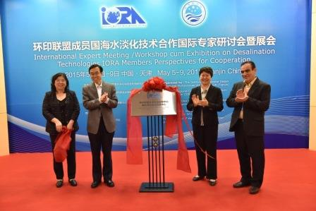
The Inauguration ceremony for IORA RCSTT Regional Coordination Center for Desalination Technologies in IORA Region.
Considering the importance of continued technical transfer or exchange, training, standardization cooperation on Desalination Technologies in the Region, the participants expressed unanimously that the conference/workshop has been a resounding success in coming out with focused recommendations and actions as below:
I. IORA RCSTT Coordination Center for Desalination Technologies was officially set up at ISDMU.
II. Improving cooperative mechanism of seawater desalination in the region among the related R&D institutions and private sector.
III. The programme certainly would help the participants in forming deeper understanding of seawater technology in China and laid the foundation of technical cooperation and transfer on seawater desalination among the member states through the region for the benefit of all the involved countries.

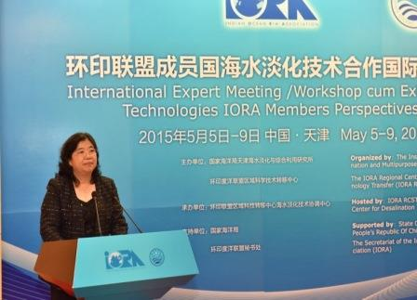

The participants have agreed on the following issues:

1- The participants have resolved to continue the organizing workshops, conferences and/or expert meetings on Desalination. These events should be organized annually by IORA RCSTT Coordination Center for Desalination Technologies through IORA RCSTT secretariat, each time hosted by one country which is voluntarily selected in the previous meeting. It was proposed that the next activity of workshop/conference may be hosted by Sri Lanka (tentatively in May 2016) or South Africa in 2016，however the Royal Thai government may host the same programme in 2017.
2- The participants have expressed their support that a technical visit in countries with potential demands for desalination technologies should be annually arranged by IORA-RCSTT Coordination Center for Desalination Technologies through IORA RCSTT secretariat, to bring consultant service and solutions to relevant problems. It was proposed that the first such visit should take place to Sri Lanka to explore the possibility of installing the desalination unit for water purification for public use through support of Chinese government. The tentative date of visit by experts will be in November 2015 upon invitation from Sri Lanka. Mozambique has also expressed interest on this issue.
3- IORA RCSTT Coordination Center for Desalination Technologies will try to establish a special scholarship to subsidize experts or overseas students at ISDMU, including training program in China, to improve technological level of seawater desalination in the region.
4- The Member States have been requested to nominate one of their centers of excellence to be the Focal Point for IORA RCSTT Coordination Center for Desalination Technologies for enhancing technical cooperation in IORA region.
