REPORT ON THE THIRD MEETING OF MEDICINAL PLANTS FOCAL POINTS OF IORA RCSTT Jakarta, Indonesia May, 10 – 12, 2017

“Synergism between Academician, Business and Government in the Development of Medicinal Plant Products: Utilization of Evidence-Based Research”
The Third Meeting of Medicinal Plants Focal Points of IORA RCSTT was held from 10-12 May 2017 in Jakarta, Indonesia. The meeting was organized by the National Agency of Drug and Food Control (BPOM) of the Republic of Indonesia in collaboration with IORA Regional Centre for Science and Technology Transfer (IORA RCSTT), supported by IORA Secretariat and the Ministry of Foreign Affairs, Republic of Indonesia.

Opening Ceremony
The Meeting was officially opened by Drs. Ondri Dwi Sampurno, Apt, M.Si, Deputy for Traditional Medicines, Cosmetics and Complementary Products Control, BPOM, on behalf of Chairperson of BPOM. The meeting was attended by government, academician, and business sector responsible for medicinal plants products development from 11 IORA member countries, namely; the Republic of India, the Republic of Indonesia, the Islamic Republic of Iran, the Republic of Kenya, the Republic of Malaysia, the Republic of Mauritius, the Republic of Mozambique, the Sultanate of Oman, the Democratic Socialist Republic of Sri Lanka, the United Republic of Tanzania, the Kingdom of Thailand, and dialogue partner the People’s Republic of China.
The Meeting was convened with the theme “Synergism between Academician, Business and Government (ABG) in the Development of Medicinal Plant Products: Utilization of Evidence-Based Research”. The objectives of the meeting are to share information and exchange of views on framework of collaboration amongst ABG in developing medicinal plant products, as well as promoting

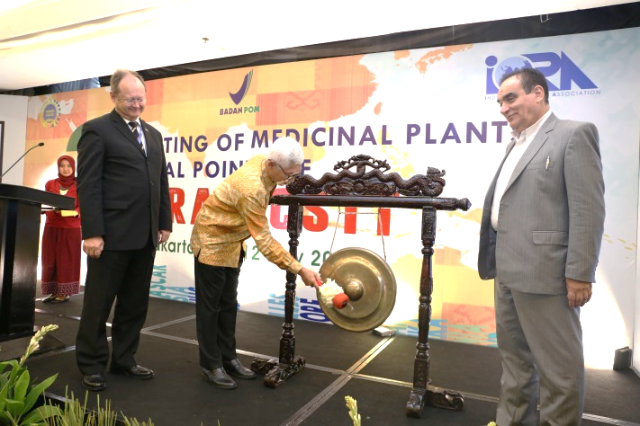
research interest on medicinal plants that could be applied and comply with the market need, either to be commercialized as an over-the-counter products or to be used and integrated within the national health system.

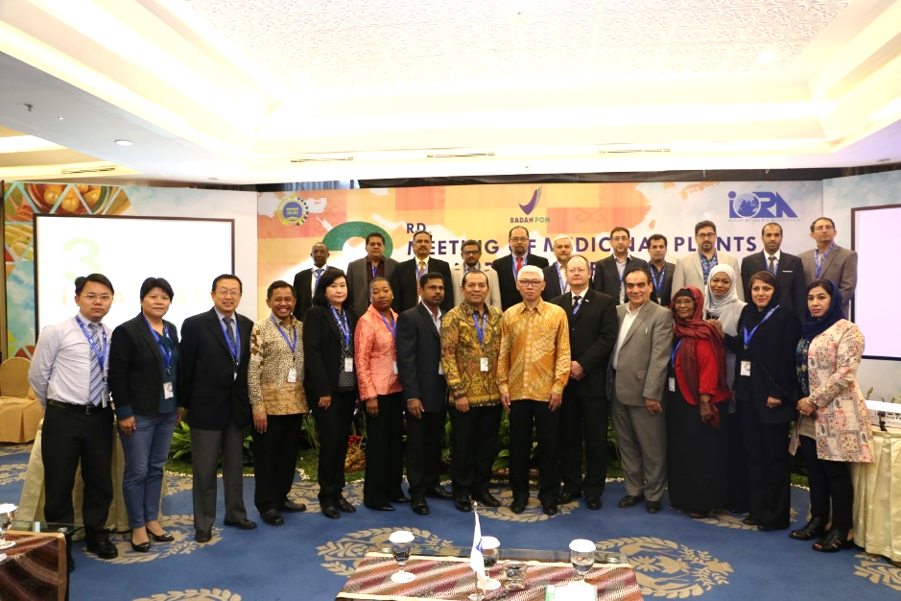

Topics of the Meeting
Totally, 16 presentations which focused on four main issues were presented during the 2 – days meeting by the delegates from the participant countries, and could be resumed as follows:
- Policy in synergizing ABG in medicinal plants products development
Main issues on medicinal plant products development are among others : availability of medicinal plants as raw materials (quantity, quality, sustainable use as well as conservation and cultivation practices); consistency of good manufacturing practices (GMP) implementation; proof on efficacy particularly through clinical data; lack of numbers and competencies of researchers; the existence as well as compliance of standard, guideline, policy and regulation on medicinal plants and its products and finished goods; compliance on safety, quality and efficacy requirements; innovation and technology of raw material and finished products; national and international database on genetic resources and traditional knowledge; intelectual property rights; commercialization of products; integration into national health system.
It is undeniable that the development of medicinal plant products is strongly associated with the roles of various stakeholders including government, academician and business. The key point is how to direct efforts made by those parties toward a synergize way. Somehow there is still a lack of coordination amongst them: each parties are ‘doing their own business’ in term of too many roadmap; involvement of too many government agencies in managing research grants and establishing research centers on natural products and herbal medicines, leading to uncoordinated and unfocused research activities; little involvement of industries and multinationals company in R & D activities; etc. In order to gain the mutual collaboration amongst ABG, it is essential to promote partnerships among academia (researchers), as well as partnerships between academia and the companies, governments, or nongovernmental/nonprofit organizations. As an initiation, ABG frequently organize meetings, forums, workshops, conferences and seminars to discuss planning, strategy and implementation of programs for the development of medicinal plants products.
Academia play an important role in helping regulatory agencies keep informed on challenges and opportunity brought by science, whether it in the context of the development, assessment or safety monitoring of medicinal plant products; facilitating research in collaboration with the business sector as this field area is their capability (with support of research facility and competency of human resources (researchers). When academia doing an evidence based research on medicinal plant products, some considerations should be made such as: economic value, products could be commercialized and in-line with the diseases pattern trend; appplicable for manufacturing scale; quality and quantity of evidence based research; compliance to the regulatory; knowledge and technology transfer between research institutions and industry.
The government should have strong policy on the development of medicinal plant products and supports it with regulation, standard and guideline without compromising with consumer protection; including: intelectual property right; insentive for research (grant, tax reduction for researchers, etc.); integration of medicinal plants product into National Health System; technical assistance and capacity building programs especially for SMEs; facilitation of collaboration between academicians and business sector in conducting research of medicinal plants product; facilitation of market access and promotion of medicinal plants product. Furthermore, the government should make effort on raising awareness of the mandate and work of the regulatory agencies network to increase academia’s trust in and engagement with the regulatory system.
Business sectors should set up a priority scale in developing and commercializing products; conduct partnerships with academicians on medicinal plant products research, implementing GMP consistently, ensuring the sustainability of herbal raw materials as well as responsibility in post-marketing surveillance.
2. Opportunities and challenges in medicinal plant products research: steps in overcoming gap between initial discovery and a viable products idea
There are some approaches in conducting medicinal plants research, e.g. conventional approaches (based on empirical knowledge to active constituent screening of the plants, pre clinical and clinical test), reverse approach (jamu saintification in Indonesia), product development based on known active constituent. In choosing medicinal plants for developing products, researchers should pay attention to several aspects, e.g. plants status (easy to be obtained or cultivated, sustainable and ensure the plants species), claim/indication (broad indications needed by the people, note to safety concern, and aware about the possibility of interaction).
Collaborative research activities between academia and business is might be a promising way to overcoming gap between initial research to a viable products. The collaborative research activities could be start from setting up the partnership; taking the partnership forward by facilitating aspects and overcoming challenges in collaborative research, dealing with intellectual property rights (IPR shall be applied from discovery stage until product development). Furthermore, institutional support to collaborative research is indispensable, e.g. the research dissemination strategies such as scientific workshop and conferences, institution/research unit website, dedicated website focusing on transfer and collaboration activities, research fair events, etc.
3. Business perspective in medicinal plants products development and commercialization
The biosciences would be the next wave of innovation in products and services, across a range of economic activities in health, agriculture, industry and even in energy. In conducting development of medicinal plants products, business need government’s support in the existence of standards, guidances, protocols, policies and regulation as references. Business sectors acknowledge the importance of development of evidence-based products. Research on herbal medicine must embrace state-of-the art technologies to include genomics, system pharmacology, supported by quality system of productions. When designed properly and developed through clinical trials, medicinal plants products can be a superior as a medical therapeutics.

4. Efforts in bridging innovation in medicinal plant products and commercialization
In order to enhance the potential contribution of herbal medicine to health, wellness and people centered-health care, the medicinal plants products have to be of high quality, safe and offer health benefits. There should be sufficient scientific information available on the products such as their ingredients, indications, dosage, pharmacology, contraindications and side effects. Post-marketing surveillance and public empowerment should be a shared-responsibility for both the government and business company as the producer.
Developing a consortium for bridging the gap between researchers and industry, by involving the government are being started in some member states. Objectives of the consortium are: supporting research and development; suggesting mechanisms for financing the consortium activities and projects; supporting for establishing required of reference standards for material and finished products; assisting in issues on legal framework and patenting; supporting SMEs in research and development activities; expanding regional and international market opportunity; capacity building; supporting general activities of workshops and conferences.

Technical Visit Program
Prior to the meeting, the participants also took part in a technical visit to Dexa Laboratories of Biomolecular Sciences (DLBS) and Kampoeng Djamoe Martha Tilaar, in Cikarang - West Java. sDLBS is a part of Dexa Medica Group, one of Indonesia's pharmaceuticals industry, which produces herbal medicine active ingredients or bioactive fraction. DLBS develop natural products through pharmacological characterization in vitro and in vivo, clinical data for efficacy and safety study, as well as international standard dossiers. Dr. Raymond Tjandrawinata, the Executive Director of DLBS, gave a presentation of DLBS company profile. All the participants had also a site visit to DLSB laboratories facility.
Kampoeng Djamoe Organik or more popular as KaDO, is a reflection of the strong commitment of Dr. Martha Tilaar’s, founder of Martha Tilaar Group (one of Indonesia’s herbal medicine and cosmetics companies), on developing Eastern beauty products with locally-based materials, and at the same time raising “Jamu” as Indonesia local wisdom which has been promoted globally and as an attempt to preserve biodiversity of Mother Earth. The main objective of KaDo is to become an organic herb garden and to provide a holistic education program to enhance our physical, spiritual and moral balance. KaDO has collected more than 600 species of Indonesia original MAC (medicinal, aromatic, and cosmetical) plants.

