
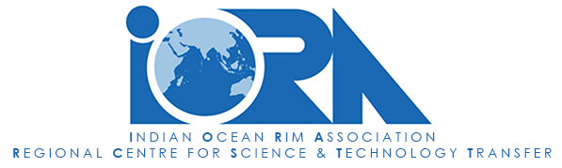

The Webinar on Seawater Desalination and Multipurpose Utilization in the Indian Ocean Region

AGENDA

Date: 26 November 2025 Mauritius Time: 11:00 – 14:00 (GMT+4)
Format: Online

11:00 – 11:20  Opening Session | Welcome and Opening Remarks by:  - Ms. Zelda Vrolick, Director, IORA Secretariat  - Mr. Selby Modiba, Deputy Chair IORA WGSTI  - Mr. Xiang Wenxi, Director of ISDMU, Ministry of Natural Resources, China (TBC)  - Dr. M. Sanjabi, Director, IORA RCSTT
11:20 – 12:20  Keynote Speeches | - Solar Desalination Technologies: From Concept to Sustainable Practice (20 min)  Dr. Shokrollahzadeh, PhD  Professor in Chemical Engineering,  The project manager of the "Comprehensive Study on Dual Purpose Desalination (Simultaneous Desalination and Salt Production)”  Valuable Product Recovery from Seawater Desalination Brine (20 min)  Prof. Alison Lewis,  Director, Crystallization and Precipitation Research Unit  Chemical Engineering Department, University of Cape Town, South Africa  - Technical Progress in coupling ocean energy with seawater desalination (20 min)  Dr Xie Chungang,  Vice director of Desalination Technology Research Department, ISDMU, Ministry of Natural Resources, China
(Followed by 5 minutes of Q&A / transition)

12:20 – 13:40  Thematic Session:  Technology, Environmental Management, and Policy Frameworks  Session Panelists:  Dr. S. Shokrollahzadeh, Professor in Chemical Engineering,  The RCSTT project manager of the "Comprehensive Study on Dual Purpose Desalination”  Dr. Alamolhoda,  Ex-Director, Institute of Water and Energy, Sharif University of Technology, Iran | (Approx. 15 minutes per presentation, plus short transitions)  Topic 1: MoES-NIOT Efforts on Sea Water Desalination in Lakshadweep Islands  Dr. S V S Phani Kumar  Group Director, Water and Climate Change  Scientist G, National Institute of Ocean Technology, Chennai, India  Topic 2：The Multi-length Scale Structure of Polyamide TFC RO Membranes  Dr. Wang Jian, ISDMU, Ministry of Natural Resources, China  Topic 3: Brine Mining Technologies and Typical Cases  Dr. Luo Bijun, ISDMU, Ministry of Natural Resources, China  Topic 4: Global trends of seawater desalination research: An AI-assisted bibliometric analysis during 2019–2024  Dr. Song Hanwen, ISDMU, Ministry of Natural Resources, China  Topic 5: Global Outlook for Desalination and Comprehensive Utilization of Seawater  Mr. Hugo Birch, Global Water Intelligence  Topic 6: Survey on Seawater Desalination Possible Effects on Salinity Changes in the Persian Gulf  Dr. Reza Shahifar, HSE Manager of Asia Water Development Engineering Company, Iran
13:40 – 13:55  Open Discussion and Q&A | - Interventions and comments from IORA Member States and Dialogue Partners
13:55 – 14:00  Closing Remarks | - Summary of key takeaways and future cooperation opportunities by RCSTT  - Closing statements by RCSTT

