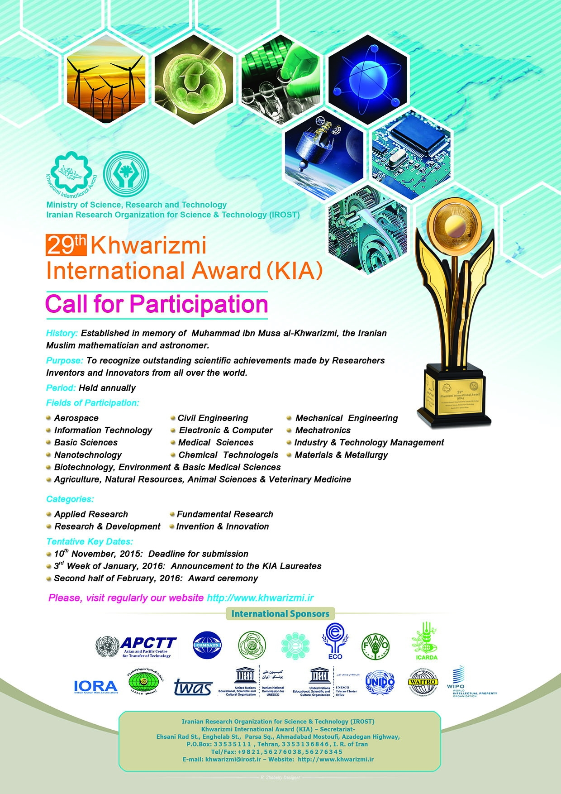

29th Khwarizmi International Award (KIA), February, 2016

29th Khwarizmi International Award (KIA) was held in February, 2016 in Tehran, Iran.

