The Second Meeting of Medicinal Plants Focal Points of IORA RCSTT cum Exhibition - Lucknow, India - March 18 – 19, 2015

The Second Meeting of Medicinal Plants Focal Points of IORA RCSTT Cum Exhibition was held in Lucknow, Republic of India during 18–19 March, 2015. This meeting was jointly organized by Central Institute of Medicinal and Aromatic Plants (CSIR – CIMAP) and IORA Regional Centre for Science and Technology Transfer (IORA RCSTT) and supported by the Ministry of External Affairs, Government of India.
The meeting was attended by Director of CSIR – CIMAP, Prof. Dr. Anil Kumar Tripathi; Director of IORA RCSTT, Dr. Mahmoud Molanezhad; Principal Secretary of Horticulture of UP Government, Mr. Shri Deepak Trivedi; Chief Executive Officer of National Medicinal Plants Board, Ms. Meenakshi Negi; Chairman of Scientific Body of Pharmacopoeia Commission for Indian Medicines (PCIM), Dr. Sukhdev Swami Handa; experts from IORA Region (Bangladesh, Egypt, Indonesia, Iran, Malaysia, Seychelles, South Africa, Sri Lanka, Sultanate of Oman, Tanzania, and Thailand); and IORA private sector from India and Iran.

Opening Ceremony
During the opening ceremony of the meeting, welcome and opening remarks were given by Prof. Dr. Anil Kumar Tripathi, and the keynote speech by Dr. Mahmoud Molanezhad and Mr. Shri Deepak Trivedi. Also, a presentation on medicinal plants status and business in India has been given by Ms. Meenakshi Negi and a valuable lead lecture by Dr. Sukhdev Swami Handa. Finally, the ceremony ended with photo session and dedication of monument.
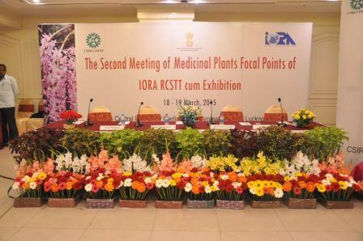

Objectives of the Meeting
This programme covered issues on the status of quality standards and standardization of medicinal plants and products in IORA member countries and dialogue partners. Based on the objectives of the meeting, the issue and challenges in harmonizing the common minimum quality standards (CMQS) for medicinal plants and herbal medicines to introduce a system of certification acceptable to all Member States was discussed. The discussion was aimed for commercialization and trade facilitation of knowledge-based products of medicinal plants and related technologies in the IORA region.

Presentations and Visits
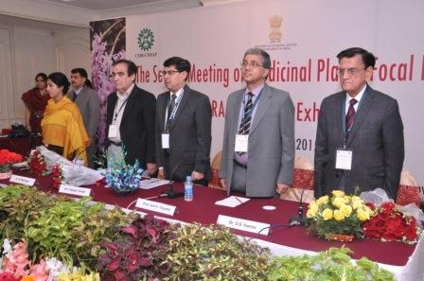
Totally, 15 presentations (including country report) which mainly focused on the above topics were presented during the 2 – days meeting by the delegates from the participant countries. On the first day, after the meeting was ended, all the participants had a study visit from CSIR-CIMAP and its facilities. In view of the experience and strength of CSIR-CIMAP in the area of Medicinal Plants it was suggested by IORA-RCSTT to make “CSIR-CIMAP” as Coordinating Centre of IORA-RCSTT for medicinal plants focal points.

Exhibition
5 Indian and 5 Iranian herbal medicines companies had the opportunity to exhibit and discuss with other participants about their products in order to promote technology transfer and commercialization of their knowledge-based products.

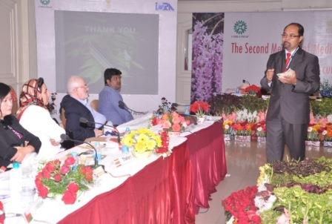

Recommendation of the Participants
Following major recommendations emerged after two-day deliberations among the participants:
- To characterize medicinal plants (considering the individual country position) used in traditional system of medicine including safety and efficacy via traditional usage.
- To develop standard protocols for quality of identified genotypes of species, their cultivation, quality control of their harvested products, clean post-harvest processing, product formulation and storage of materials and related final products in suitably controlled environment.
- To promote cultivation of characterized medicinal plants using improved planting material varieties / genotypes, which give optimum yields of raw herb and / or marker constituent(s) per unit area.
- To procure the medicinal plants from the cultivated sources from within and among IORA Member States for development of herbal products. Effort should be made to make similar strategy for medicinal plants of perennial nature.
- To develop human resources in all fields of the enterprise (in different areas like cultivation, processing, manufacturing, value addition, quality testing, marketing, etc) through training and educational programmes for capacity building.
- Harmonization of regulations for quality control and trade among the member countries, for the purpose of international consumption of products.
- Sharing knowledge, know-how, services, facilities through regular interactions, visits, technology transfer, etc.
- To formulate the strategy for the protection of intellectual property rights (IPR) and continued improvements in the regulations and benefit sharing in the area of medicinal plants.
- All above should be integrated with the cultural and traditional knowledge and faith being pursued in the respective regions.
- It has also recommended that each Member State may identify at least 10 medicinal plants of economic and medicinal importance of human / veterinary usage and work out the above parameters for them for exchange of information and benefit for the whole region.
- The Director of IORA-RCSTT indicated that the Medicinal Plants Focal Points shall take the necessary steps to complete the information required to be published on the IORA MPNet (Medicinal Plants Network of Indian Ocean Rim Association) enabling IORA Member States to enhance their cooperation by using the above network and its related information.
- The Science and Technology Park of Lorestan has proposed that the park may invite the technology parks in IORA Member States to initiate future collaboration in medicinal plants in this region in 2015" in the Lucknow Declaration.
It was recommended that the tentative next host countries to host the Third Meeting of Medicinal Plants Focal Points of IORA RCSTT, other related institutions and private sector in 2015 and 2016 could be Malaysia, Sri-Lanka and Seychelles.
All the representatives of the member nations agreed upon the above points.

Closing Ceremony
At the end of the meeting, during closing ceremony, all the participants were granted the certificate of attendance at the meeting and finally, the organizers provided archaeological sites visit to all the attendees in Lucknow, India on March 19, 2015.

International Conference
After the meeting, the participants also were invited to attend the “International conference on Medicinal plants: Resource for affordable new generation healthcare” on March 20-22, 2015 and the organizing committee had waived off the registration fee for the participants from IORA Region. The topics for the main technical sessions and poster presentations were as follows:
- Genotypes and chemotypes - Prospection and conservation
- Healing herbs in traditional systems of medicine
- Botanical dietary supplements – Expanding markets
- Quality standards and safety regulations for herbs and herbal products
- Emerging global markets and challenges: Industrial perspective
- Industry–Farmer partnership for employment and livelihood security
- Policy issues for conservation, cultivation, quality control, trade and intellectual property In this context, the number of IORA Participants had presented their papers which they received certificate of excellence from the organizers.

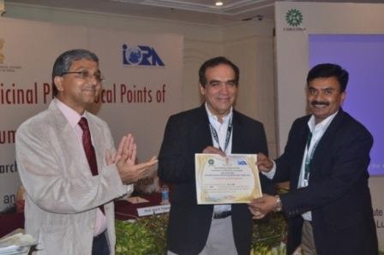

Acknowledgment
The delegates expressed their satisfaction for the success of the meeting in achieving the objectives and in coming up with focused recommendations for subsequent actions to be taken up by the Member States. The delegates also expressed their gratitude to Ministry of External Affairs, Government of India, IORA-RCSTT, CSIR, New Delhi and CSIR-CIMAP Lucknow for organizing this meeting successfully. These would help in improving the environment of cooperation among the IORA Member States in formulating the plans to ensure continued cooperation in the field of research, technology transfer and commercialization of Medicinal Plants and Herbal Medicines in the IORA region.
It is worth mentioning that the government of India generously has supported this programme providing air ticket and local hospitality to one participant from each Member States and local hospitality to second participant and extra support of local hospitality to 10 private sector participants during this programme.

