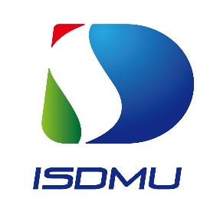

The Webinar on
Seawater Desalination and Multipurpose Utilization in the Indian Ocean Region

Date: 26 November 2025 Time: 14:00 – 17:00 (GMT+5:30)
Format: Online

REGISTRATION FORM

Member State/Country
Full Name (Mr/Mrs/Ms)
Designation
Participation Level | Participant
Participation Level | Speaker / Presenter
Ministry/Institution/ Organization/ Company
Position/ Title/ Rank
Mobile
Email
Confirm Attachments (for speakers/presenters) |  | Short bio (200 words max.)
Confirm Attachments (for speakers/presenters) |  | Abstract of Presentation (250-300 words max.)
Confirm Attachments (for speakers/presenters) |  | Full Presentation File

